Icc UI Trace

Go to the path from where you launch configurator and open cmd here

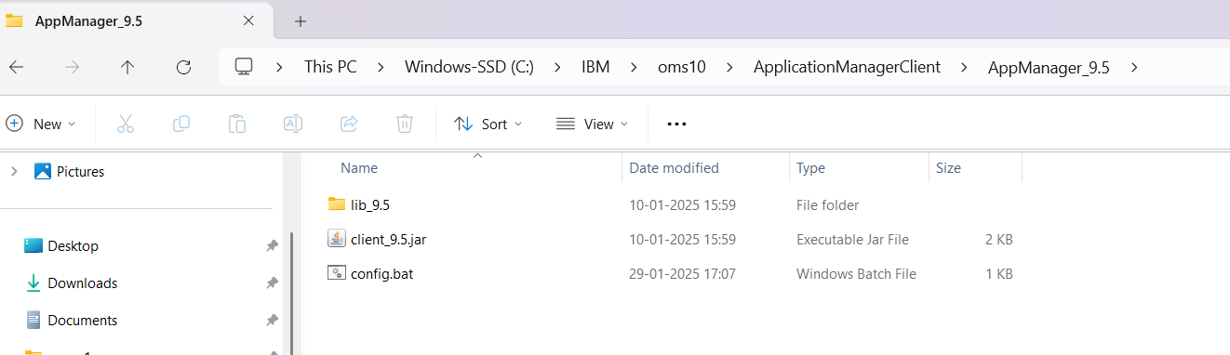

Run the command

java -jar client_9.5.jar -mode smc

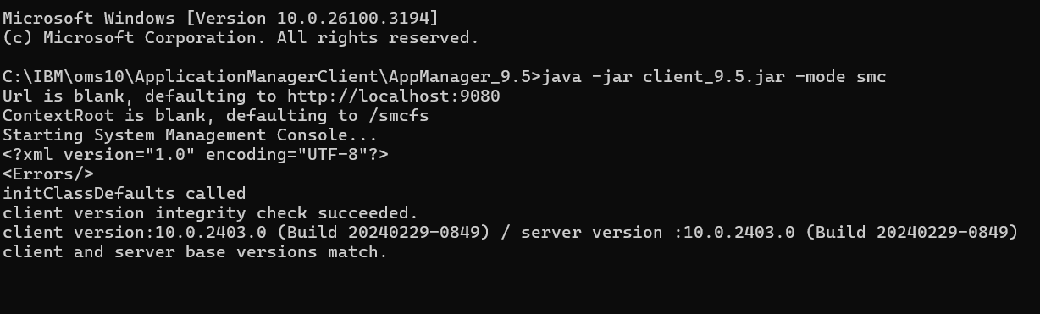

Go to tools and apply traces

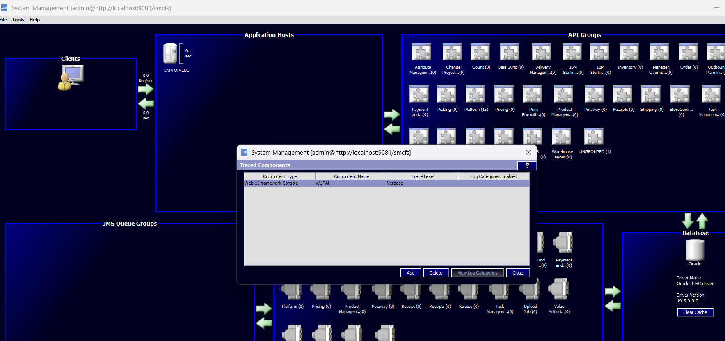

You can call modify traces api as well

<Traces>

     <Trace  Action="DELETE"  CategorySet="" Level="VERBOSE" Name="Call Center" ServerId="" TraceExpired="false" TraceKey="" TraceTTL="1440" Type="WUFConsole"/>  
</Traces>

Go to server1 and clear system.out.log and see the traces there